**Heterogeneity in lobar and near-acini deposition of inhaled aerosol in the mouse lung**

W. Gu and C. Darquenne*,

Department of Medicine, University of California, San Diego, USA

*Corresponding author: Chantal Darquenne, PhD

Department of Medicine

University of California, San Diego

9500 Gilman Drive, mail code 0623A

La Jolla, CA 92093-0623

USA

Email: cdarquenne@ucsd.edu

**ABSTRACT**

Laboratory animals are often used to derive health risk from environmental exposure or to assess the therapeutic effect of a drug delivered by inhaled therapy. Knowledge of the in-situ distribution of deposited particles on airway and alveolar surfaces is essential in any assessment of these effects. A unique database including both high-resolution lung anatomy and deposition data in four strains of laboratory mice have been recently made publicly available to the research community (<https://doi.org/10.25820/9arg-9w56>). Using these data, we investigated the effect of particle size on the distribution of deposited particles at the lobar and near-acini level. Analysis was performed on a total of 33 mice where 3, 16 and 14 animals were exposed to 0.5µm, 1µm and 2µm particles, respectively. Ratio of normalized deposition to normalized volume was calculated for each lobe (). At the near-acini level, the skew and standard deviation of the frequency distribution of particle deposition were calculated. Significant deviation above 1 was found for DV ratio in the cranial lobe (). , and were all significantly <1 and lower than (p<0.01). At the near-acini level, skew and standard deviation were positively correlated with particle size and the presence of hot spots (high deposition) were mainly found in the apical region of the lung. These results highlight the uneven distribution of deposited particles in the mouse lung. Thus, depending on the lung sample location, individual analysis to determine overall deposition may either underestimate or overestimate total lung burden, at least for micron-sized particles.

Keywords: hot spots, spatial heterogeneity, particle deposition

1. **INTRODUCTION**

Exposure to airborne particulate matter (PM) plays an important role in initiating or aggravating respiratory and cardiovascular diseases. The understanding of the pathogenic effects resulting from such a PM exposure requires knowledge of the in-situ distribution of deposited pollutants on airway and alveolar surfaces. Such knowledge is also essential in any assessment of the therapeutic effect of a drug delivered by inhaled therapy. Animal models have long been used as surrogates to predict therapeutic effects in humans or to determine possible adverse health effects arising from chemical and/or particulate exposures. Mathematical models have often been used to complement experimental studies under different exposure conditions. In addition, modeling can also be used as a tool for interspecies dose extrapolation, an important element in preclinical and toxicological studies.

In recent years, sophisticated subject-speciﬁc computational models of aerosol transport and deposition in the lung have been developed for both humans (De Backer et al., 2008; Hofmann, 2011; Kuprat et al., 2020; Ma & Lutchen, 2009; Vinchurkar et al., 2012) and research animals (Asgharian et al., 2016; Kabilan et al., 2016). These models lack subject-speciﬁc experimental validation and have been mainly validated with averaged *in vivo* deposition data from the literature. As considerable inter-subject variability exists both in airway geometry and in deposition data, there is a need for detailed subject-specific datasets of lung anatomy and site-specific deposition information. Beichel et al. recently provided such data for the mouse lung in a publicly accessible repository, the lapdMouse archive (Beichel, Glenny, Bauer, Krueger, & Lamm, 2019). This archive provides high-resolution lung models of 34 mice combined with experimental data of local particle deposition and breathing parameters measured during aerosol exposure. These data may not only be used to develop more accurate models of particle deposition in the mouse lung but can also be analyzed to better understand the interplay between lung anatomy and regional aerosol deposition among animals. The mouse is one of the most commonly used animal models in toxicological and preclinical studies. It is thus important to understand heterogeneities in deposition patterns not only within a single mouse lung but also across different strains. This is the focus of this study. In particular, we investigated the effect of particle size on the lobar distribution of aerosol deposition and also on deposition patterns at the near-acini level.

1. **METHODS**
   1. *Study data*

The data used in this study were obtained from the Lung anatomy + particle deposition mouse (lapdMouse) archive that has been described in detail elsewhere (Bauer, Krueger, Lamm, Glenny, & Beichel, 2020). Briefly, this unique database includes high-resolution anatomical data of the lungs of 34 mice that are linked to three-dimensional (3D) particle deposition maps. Mice of both sexes and of four different strains (B6C3F1, BALB/C, C57BL/6 and CD-1) were exposed to fluorescent aerosol particles with diameters of 0.5, 1.0 or 2.0 µm while free breathing in nose-only exposure chambers (Table 1). Following exposure, the lungs of these mice were imaged in a serial block-face imaging cryomicrotome at various wavelengths to isolate deposited particles and lung structure. The images were then processed to identify the 3D airway geometry and location of deposited particles. The airways from the trachea to the terminal bronchi were identified, labeled and represented as a mesh. These data were compiled by Beichel et al. (Beichel et al., 2019) in the lapdMouse archive that can be accessed at <https://doi.org/10.25820/9arg-9w56>.

|  |  |  |  |  |  |  |  |  |  |
| --- | --- | --- | --- | --- | --- | --- | --- | --- | --- |
| **Table 1.** Summary of samples from the lapdMouse archive used in this study. | | | | | | | | | |
| Particle Size | Strain and Sex | | | | | | | | Total |
|  | B6C3F1 | | BALB/c | | CD-1 | | C57BL/6 | |  |
|  | M | F | M | F | M | F | M | F |  |
| 0.5 µm | - | - | 1 | 2 | - | - | - | - | 3 |
| 1 µm  2 µm | 2  2 | 2  2 | 2  2 | 2  1 | 2  1 | 2  2 | 2  2 | 2  2 | 16  14 |
| M: male, F: female. | | | | | | | | | |

* 1. *Data analysis*
     1. *Lobar deposition.*

In order to compare aerosol particle deposition across lobes, lobar volume () was normalized by total lung volume () and lobar particle deposition () by total particle deposition in the lung (). The volume-normalized deposition fraction in each lobe (*DVlobe*)was then calculated as the ratio between normalized lobar particle deposition and normalized lobar volume, i.e.

(1)

For each mouse sample, *DV* ratios were calculated for each lung lobe: left lobe, right cranial lobe, right accessory lobe, right middle lobe and right caudal lobe (Figure 1) and denoted as , , , and .

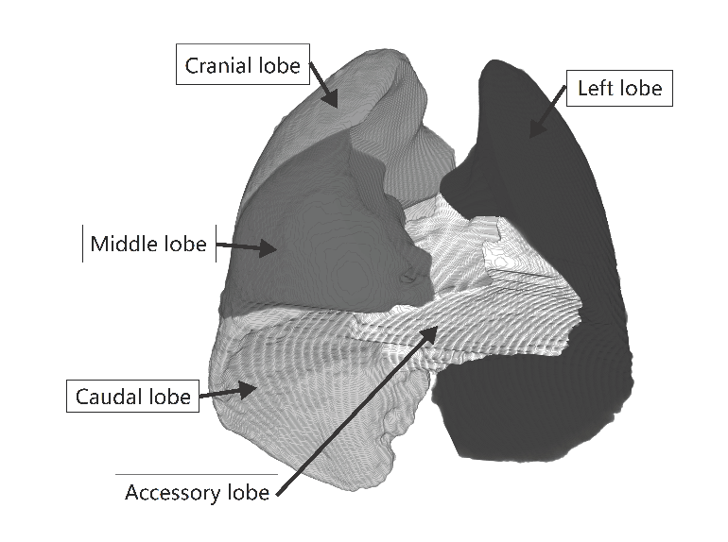

**Figure 1.**  Identification of the individual lobes of the mouse lung on a 3D reconstructed lung from mouse xx of the lapd archive.

Since is the ratio of normalized particle deposition over normalized lobar volume, it is a good indicator of the distribution of particle deposition between lobes. If the number of deposited particles is proportional to the lobar volume, ratio is one. If the number of deposited particles in a lobe is higher than the averaged whole-lung deposition, then is greater than one. Inversely, if aerosol particles are sparsely deposited in a lobe, then is less than one.

* + 1. *Near-acini deposition.*

Bauer et al. (Bauer et al., 2020) partitioned the lung of each mouse into near-acini structures of ~3 mm3 resulting in ~350 compartments/lung. For each mouse, we ranked these compartments based on the density of deposited particles as provided in the lapdMouse archive. Deposition densities (expressed in arbitrary units) ranged from 0 to 4.75, with 99.8% of the compartment having a deposition density ≤4. A forty-bin frequency distribution of near-acini particle deposition was then constructed. Any compartment with a deposition greater than four was considered an outlier and grouped together at the tail end of the distribution. Traditional measures of regional particle deposition were derived from these frequency distributions by moment analysis (Bennett, Xie, Zeman, Hurd, & Donaldson, 2015; Garrard, Gerrity, Schreiner, & Yeates, 1981): the standard deviation (*SD*) and third moment about the mean (skew, *Sk*) of the distributions were calculated as follows

(2)

(3)

where is the total number of near-acini compartments and is the average near-acini single-compartment particle deposition.

The cranial-to-caudal distribution of near-acini deposition was also calculated. For this analysis, each near-acini compartment location was identified by the distance of its centroid to a reference plane that is perpendicular to the bisector line between the main bronchi and includes the point at the intersection of the centerlines of the trachea and main bronchi. Data were then plotted as a function of distance to the reference plane. Near-acini compartments with mean deposition equal to or higher than 2.33 () standard deviations above the median were defined as hotspots and their spatial location were recorded.

* 1. *Statistical Analysis.*

ratios were grouped by particle size and strain. For each group, multiple two-tail T tests were performed to determine if ratios were significantly different from one. Paired five-way ANOVA tests were run to compare the differences of ratios across lobes. Unpaired ANOVA tests were run to compare if ratios were distinctive in different mouse samples with different strain, sex and particle size. Post-ANOVA comparisons using Bonferroni adjustment was performed for tests showing significant F ratios. ratios were also regressed on particle size. Tests with P values smaller than 0.05 were reported as significant.

The third moment and standard deviation of distributions of near-acini deposition were regressed on particle size. Unpaired T and ANOVA tests were performed to determine if distribution statistics were different across strains and sex. Tests with P values smaller than 0.05 were reported as significant.

**3. RESULTS AND DISCUSSION**

All datasets available in the lapdMouse archive were used in this study except for one (mouse m25, 2 µm aerosol) that was labeled as being of poor quality (quality C). Thus, analysis from 33 datasets are presented here (Table 1). Lobar volumes and breathing parameters used in the analysis were all provided in the lapdMouse archive and are summarized in Table 2. Lung volume are reported at total lung capacity (TLC). Breathing parameters were measured during or immediately following aerosol exposure.

|  |  |  |  |  |  |
| --- | --- | --- | --- | --- | --- |
| **Table 2.** Summary data per mouse strain for lung volumes and breathing parameters | | | | | |
| Mouse strain | N | Lung volume  (mm3) | Breathing rate  (bpm) | Tidal volume  (ml) | Ventilation  (ml/min) |
| B6C3F1 | 8 | 1105(39) | 189(26) | 0.22(0.03) | 42(11) |
| BALB/c | 10 | 1131(41) | 223(23) | 0.23(0.04) | 51(10) |
| CD-1 | 8 | 1156(124) | 233(25) | 0.24(0.03) | 55(9) |
| C57BL/6 | 7 | 1196(30) | 163(48) | 0.30(0.04) | 50(16) |
| Data are shown as mean(SD). SD: standard deviation; bpm: breath per minute | | | | | |

*3.1 Lobar deposition*

There was no significant effect of sex or strain on *DVlobe* so data were group based on particle size. ratios averaged over all mice exposed to a given particle size (mean ± SD) are listed in Table 3 and individual *DV* ratios are shown in Figure 2 where different strains are identified by different symbols. There were variations in *DV* ratios among lobes and these variations increased with increasing particle size. For mice exposed to 2 μm particles, significant deviation from 1 was found for *DV* ratio in the cranial lobe (), where deposition was relatively greater than lobar volume (P<0.001) while , and were all significantly smaller than one (p = 0.020, p < 0.001 and p < 0.001, respectively). Similar trends were found for animals exposed to 1 µm particles, however significance was not reached for . For animals exposed to 0.5 μm particles, the only *DV* ratio that was significantly different than one was (>1, p = 0.033). Finally, irrespective of particle size, showed no difference from one, indicating that particle deposition in the left lobe is proportional to the lobar volume.

|  |  |  |  |  |  |  |
| --- | --- | --- | --- | --- | --- | --- |
| **Table 3.** Averaged *DV* ratio in the lung lobes for each particle size | | | | | | |
| Particle size | N |  |  | DV ratio |  |  |
|  |  | Left | R. Cranial | R. Middle | R. Caudal | R. Accessory |
| 0.5 µm | 3 | 1.04 ± 0.11 | 1.14 ± 0.04* | 0.99 ± 0.10 | 0.89 ± 0.07 | 0.94 ± 0.05 |
| 1 µm  2 µm | 16  15 | 1.06 ± 0.11  1.04 ± 0.18 | 1.17 ± 0.11*  1.42 ± 0.34* | 0.96 ± 0.18  0.86 ± 0.19* | 0.88 ± 0.08*  0.82 ± 0.13* | 0.88 ± 0.10*  0.80 ± 0.15* |
| N: number of samples; R.: Right: *: significantly different from 1 (P<0.05) | | | | | | |

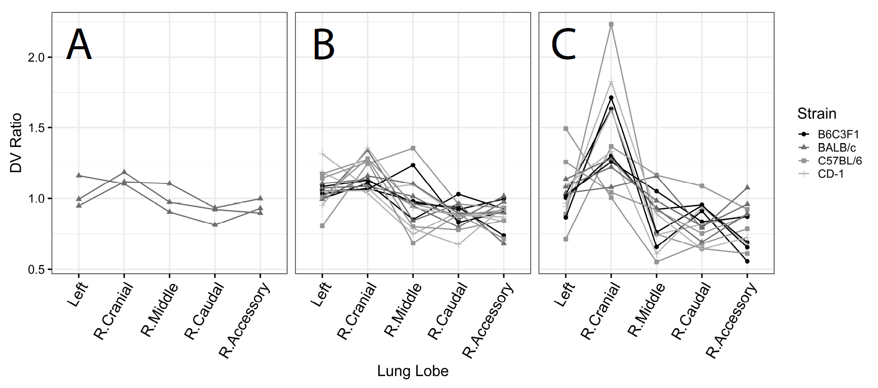

**Figure 2.**  Individual *DV* ratio for each lobe of the mouse lung. A: 0.5 µm (N=3). B: 1 µm (N=16). C: 2 µm (N=14). R.: right.

Data shown in Figure 2 and Table 3 compare well with previous studies in rodents. Brain and colleagues (Brain, Knudson, Sorokin, & Davis, 1976) delivered aerosol (MMAD=1.6 µm) to both Syrian golden hamsters and Sprague Dawley rats in animal exposure chambers and determined the distribution of deposited particles through the evenness index (EI) defined as the ratio between normalized lobar deposition and normalized lobe weight (Figure 3A). In both species, the EI was larger than one in the cranial lobe (EI = 1.42 in hamsters and EI = 1.51 in rats) while EI in the left lobe was close to one (EI = 0.98 in hamsters and EI=1 in rats). In rats, they also observed an EI < 1 in the right middle, right accessory and right caudal lobes. Morgan et al. (Morgan et al., 1983) exposed SAS/4 mice to 239PuO2 particles with a median aerodynamic diameter of 0.8, 1.5 and 2.2 µm. They observed EI larger than 1 in the cranial lobe and EI < 1 in the caudal and accessory lobe, with deviations from one increasing with increasing particle sizes, in agreement with data from this study (Table 2). Finally, in a more recent study, Yang and colleagues (Yang et al., 2019) delivered a liquid aerosol with a volume median diameter of 3.5 µm by mechanical ventilation to C57J/6 mice. Even though the particle size was larger than those used in this study, the *DV* ratio in each lobe show similar behavior as those observed in the C57J/6 mice included in this study (Figure 3B).

The distribution of deposited particles in the lung is closely linked to the distribution of inhaled air among the different regions of the lungs (Bennett et al., 2002; Moller, Meyer, Scheuch, Kreyling, & Bennett, 2009). In humans (Milic-Emili, Henderson, Dolovich, Trop, & Kaneko, 1966) and large animals such as horses (Amis, Pascoe, & Hornof, 1984), the dependent lung region gets proportionally a larger fraction of a tidal breath than the nondependent lung regions. In contrast, in small animals such as the rat, the non-dependent lung region has been reported to be better ventilated than the dependent lung region (Rooney, Friese, Fraser, Dunster, & Schibler, 2009). This may explain the higher relative deposition in the non-dependent (cranial) than in the dependent lobes of the right lung (accessory and caudal) of rodents. It should be noted that because of the size of the mouse lung, gravity is unlikely to play a significant role in the ventilation distribution among the lobes. Indeed, Rooney et al. (Rooney et al., 2009) showed that gravity had little impact on regional filling of the lungs of small rodents and that regional filling characteristics were mainly dependent on anatomy.

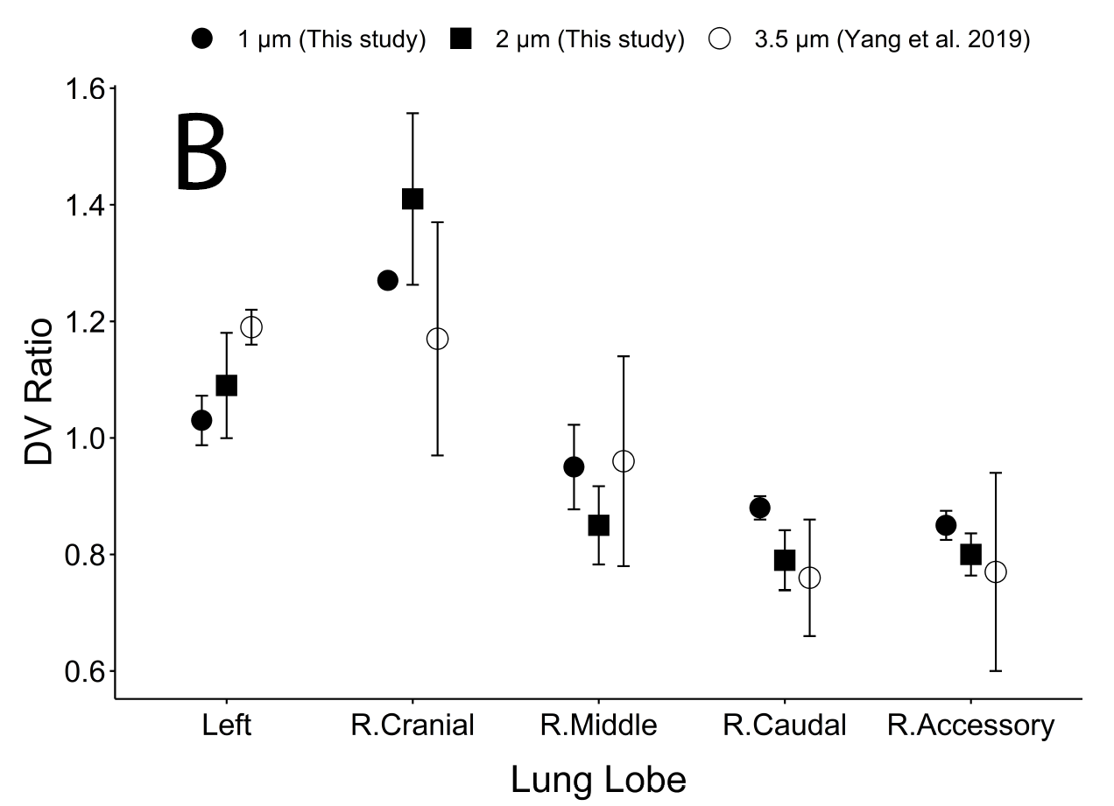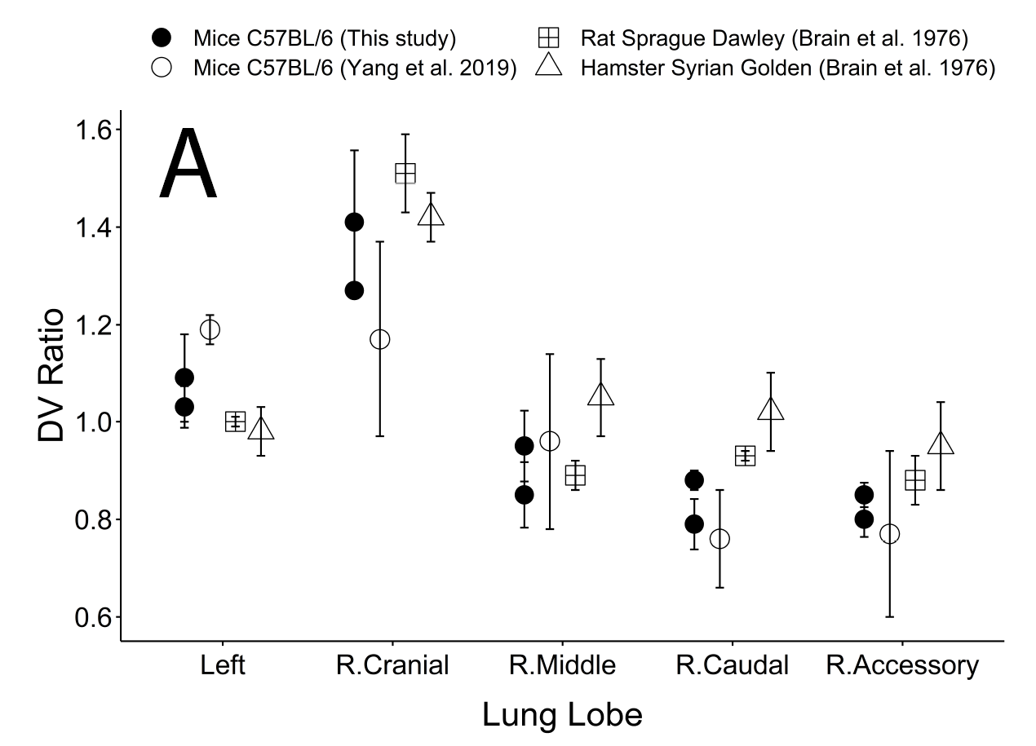**Figure 3.** *DV* ratio in each lobe of the lung. A: comparison with previous studies in rodents (Hamster, mice and rats). B: effect of particle (C57BL/6 mice only). R.: right.

*3.1 Near-acini deposition:*

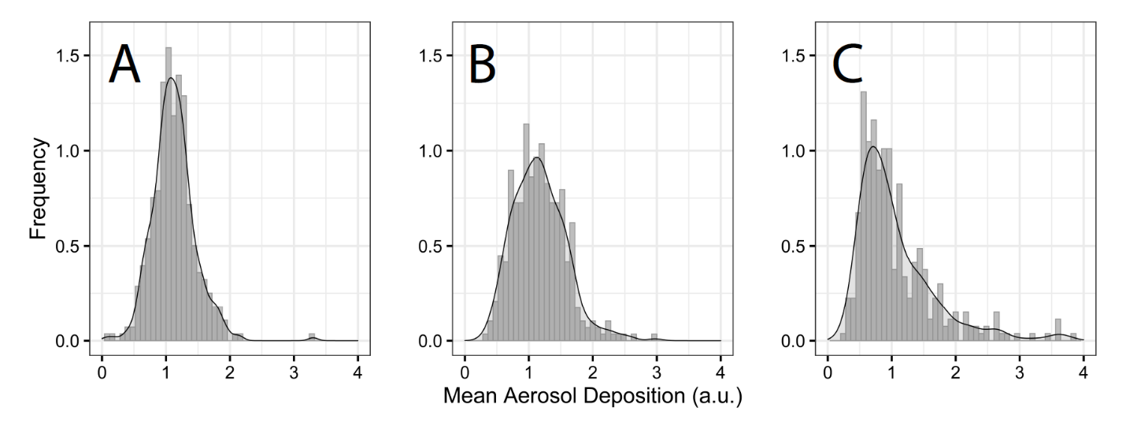The shape of the distribution of near-acini deposition was also affected by particle size. Mice exposed to small aerosol particles (0.5 µm) tended to have a narrow, i.e. homogeneous, distribution (Figure 4A). On the contrary, for mice exposed to larger aerosol particles (1 and 2 µm), the distribution of near-acini deposition tended to be wider, indicating an increase in heterogeneity of near-acini deposition with increasing particle size (Figures 4B and C).

**Figure 4.** Histograms of near-acini deposition in BALB/c mice. A: 0.5 µm. B: 1 µm. C: 2 µm. a.u.: arbitrary units.

The distributions of near-acini deposition were characterized by their standard deviation (SD) and skew (Sk). Individual data for all 33 mice samples are plotted in Figure 5 against particle size. Median, quartiles (box) and 95% intervals (vertical line) are also displayed in the figures. Both standard deviation and skew significantly increased with increasing particle size. The rather small standard deviation of near-acini deposition for 0.5 µm particles indicates a homogeneous deposition throughout the lung for these small particles. These results also suggest that the homogenous deposition observed at the lobar level still occur at the near-acini level for this small particle size.

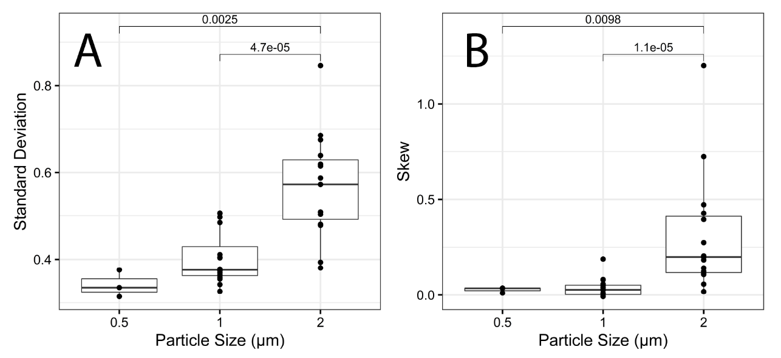

**Figure 5.** Parameters characterizing the near-acini deposition. Individual data are shown (closed symbols) along with the median and quartiles (box) and 95% confidence interval (vertical line). Significant p values are also shown. A: Standard deviation. B: Skew.

For all mice and particle sizes, skew was positive, i.e. the distribution was right-skewed. It has been previously shown that skew is a measure of hot spots of deposited particles. The larger the skew is, the more “hot spots” there are, i.e. the more there are near-acini units with higher particle deposition (hot spots) than expected from a normal distribution (Darquenne et al., 2013). Previous studies in humans showed that skew was inversely correlated with alveolar deposition (Garrard et al., 1981), implying that high values of skew are indicative of hot spots of deposited particles occurring predominantly in the bronchial airways. To our knowledge, there are no reports of skew of deposition distribution in rodents. Figures 6A-C display the location of the top 1% of near-acini deposition relative to the airway tree structure for mice exposed to 0.5, 1 and 2 µm particles, respectively. Interestingly, the hot spots, while located relatively centrally, were only present in the apical region of the lungs, i.e. in the right cranial lobe and in the upper portion of the left lobe. There was also a significant effect of spatial location in the cranial-to-caudal direction on near-acini deposition with deposition being on average higher near the cranial region towards the caudal region of the lung (Fig. 6D-F). The slopes of the regression lines were all significant (p<0.001) and increased with increasing particle size. Data shown in Figure 6 are from the same BALB/c mice as those used in Figure 4 but similar distributions of near-acini deposition were found in all of the 33 samples but one.

These observations may explain the higher deposition measured in the right cranial lobe (Figure 2). As discussed above, the non-dependent region of the rodent lung is better ventilated than the dependent region (Rooney et al., 2009). Because there is no major difference in the diameter of the airway of a given generation between lobes of the mouse lung (data not shown), higher ventilation in the apical region of the lung results in higher velocities in the airways from the apical region than in similar airways located at the base of the mouse lung. These high velocities increase the probability of a particle depositing by inertial impaction at airway bifurcation and thus increase the potential for the generation of hot spots. Indeed, of the three main mechanisms of aerosol deposition in the lung (inertial impaction, gravitational sedimentation and Brownian diffusion), inertial impaction is the only velocity-dependent mechanism (Darquenne, 2012).

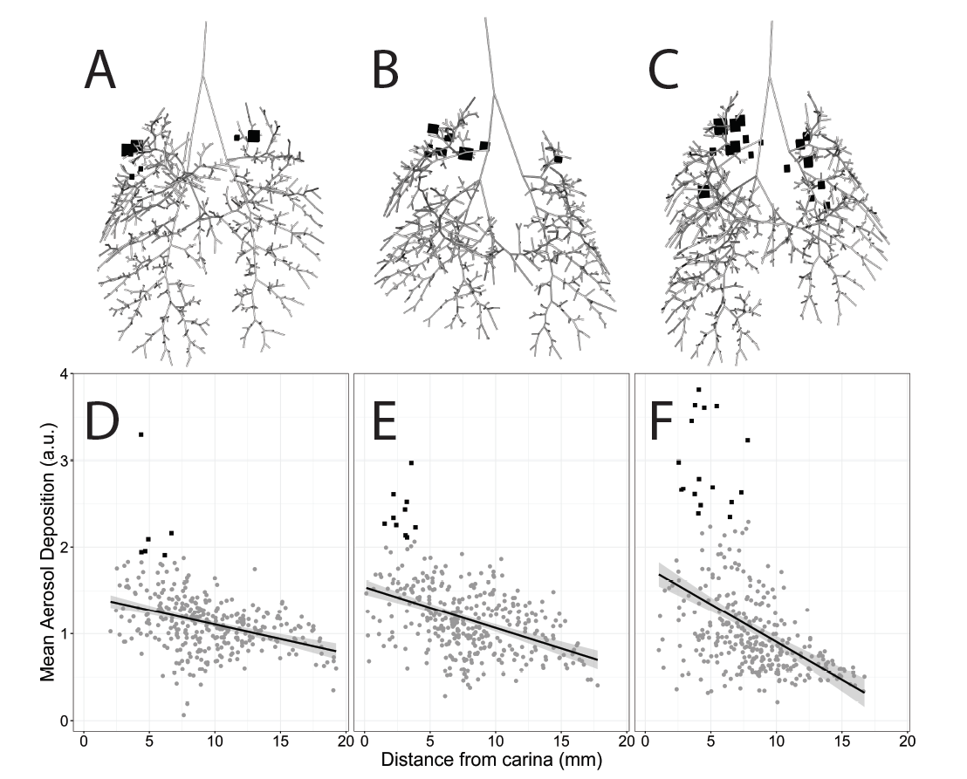

**Figure 6.** Spatial location of the top 1% near-acini deposition (hot spots) and cranial-to-caudal distribution of near-acini deposition in the same BALB/c mice as in Figure 4. Hot spots were mainly located toward the cranial region of the lung (identified by black squares in all panels). A, D: 0.5 µm. B, E: 1 µm. C, F: 2 µm. See text for details.

**4. SUMMARY**

Analysis was performed on the newly available lapdMouse archive to determine the heterogeneity of aerosol deposition at the lobar and near-acini scale in the mouse lung. The distribution of deposited particles among lobes was uneven with deposition in the cranial lobe being relatively greater than lobar volume and deposition in the middle, caudal and accessory lobes being relatively lower than their volume. There was also a particle size effect on lobar deposition unevenness that increased with increasing particle size (0.5 – 2 µm). At the near-acini level, larger particle size was associated with a less uniform spatial distribution of particle deposition and a higher likeness of formation of hot spots mainly in the apical region of the lung.

**ACKNOWLEDGEMENTS**

The study was funded by the National Institutes of Health (U01ES028669 from the NIEHS).

**DECLARATION OF INTERESTS**

The authors declare that they have no known competing financial interests or personal relationships that could have appeared to influence the work reported in this paper.

**REFERENCES**

Amis, T. C., Pascoe, J. R., & Hornof, W. (1984). Topographic distribution of pulmonary ventilation and perfusion in the horse. *Am J Vet Res, 45*, 1597-1601.

Asgharian, B., Miller, F. J., Price, O., Schroeter, J. D., Einstein, D. R., Corley, R. A., & Bentley, T. (2016). Modeling particle deposition in the pig respiratory tract. *Journal of Aerosol Science, 99*, 107-124.

Bauer, C., Krueger, M. A., Lamm, W. J., Glenny, R. W., & Beichel, R. R. (2020). lapdMouse: associating lung anatomy with local particle deposition in mice. *Journal of Applied Physiology, 128*, 309-323.

Beichel, R. R., Glenny, R. W., Bauer, C., Krueger, M. A., & Lamm, W. J. (2019). Lung anatomy + particle deposition (lapd) mouse archive. University of Iowa.

Bennett, W. D., Brown, J. S., Zeman, K. L., Hu, S. C., Scheuch, G., & Sommerer, K. (2002). Targeting delivery of aerosols to different lung regions. *J Aerosol Med, 15*, 179-188.

Bennett, W. D., Xie, M., Zeman, K., Hurd, H., & Donaldson, S. (2015). Heterogeneity of Particle Deposition by Pixel Analysis of 2D Gamma Scintigraphy Images. *Journal of Aerosol Medicine and Pulmonary Drug Delivery, 28*, 211-218. doi: 10.1089/jamp.2013.1095

Brain, J. D., Knudson, D. E., Sorokin, S. P., & Davis, M. A. (1976). Pulmonary distribution of particles given by intratracheal instillation or by aerosol inhalation. *Environmental Research, 11*, 13-33.

Darquenne, C. (2012). Aerosol deposition in health and disease. *J Aerosol Med Pulm Drug Deliv, 25*, 140-147. doi: DOI: 10.1089/jamp.2011.0916

Darquenne, C., Zeman, K. L., Sa, R. C., Cooper, T. K., Fine, J. M., Bennett, W. D., & Prisk, G. K. (2013). Removal of sedimentation decreases relative deposition of coarse particles in the lung periphery. *Journal of Applied Physiology, 115*, 546-555. doi: doi:10.1152/japplphysiol.01520.2012

De Backer, J. W., Vos, W. G., Gorle, C. D., GermonprÇ, P., Partoens, B., Wuyts, F. L., . . . De Backer, W. (2008). Flow analyses in the lower airways: Patient-specific model and boundary conditions. *Med.Eng.Phys., 30*, 872-879.

Garrard, C. S., Gerrity, T. R., Schreiner, J. F., & Yeates, D. B. (1981). The characterization of radioaerosol deposition in the healthy lung by histogram distribution analysis. *Chest, 80*(suppl), 840-842.

Hofmann, W. (2011). Modeling inhaled particle deposition in the human lung: A review. *Journal of Aerosol Science, 42*, 693-724.

Kabilan, S., Suffield, S. R., Recknagle, K. P., Jacob, R. E., Einstein, D. R., Kuprat, A. P., . . . Corley, R. A. (2016). Computational fluid dynamics modeling of Bacillus anthracis spore deposition in rabbit and human respiratory airways. *Journal of Aerosol Science, 99*, 64-77.

Kuprat, A. P., Jalali, M., Jan, T., Corley, R. A., Asgharian, B., Price, O., . . . Darquenne, C. (2020). Efficient bi-directional coupling of 3D Computational Fluid-Particle Dynamics and 1D Multiple Path Particle Dosimetry lung models for multiscale modeling of aerosol dosimetry. *J Aerosol Sci, submitted to special issue*.

Ma, B., & Lutchen, K. R. (2009). CFD simulation of aerosol deposition in an anatomically based human large-medium airway model. *Annals of Biomedical Engineering, 37*, 271-285.

Milic-Emili, J., Henderson, J. A. M., Dolovich, M. B., Trop, D., & Kaneko, K. (1966). Regional distribution of inspired gas in the lung. *Journal of Applied Physiology, 21*, 749-759.

Moller, W., Meyer, G., Scheuch, G., Kreyling, W. G., & Bennett, W. D. (2009). Left-to-right asymmetry of aerosol deposition after shallow bolus inhalation depends on lung ventilation. *J Aerosol Med Pulm Drug Deliv, 22*, 333-339.

Morgan, A., Black, A., Moores, S. R., Pritchard, J. N., Walsh, M., & Lambert, B. E. (1983). Alveolar Deposition of Sized Particles of 239 PuO2 in the Mouse. *Radiation Research, 93*, 85-92.

Rooney, D., Friese, M., Fraser, J. F., Dunster, K. R., & Schibler, A. (2009). Gravity-dependent ventilation distribution in rats measured with electrical impedance tomography. *Physiological Measurement, 30*, 1075-1085.

Vinchurkar, S., De Backer, L., Vos, W., Van Holsbeke, C., De Backer, J., & De Backer, W. (2012). A case series on lung deposition analysis of inhaled medication using functional imaging based computational fluid dynamics in asthmatic patients: Effect of upper airway morphology and comparison with in-vivo data. *Inhalation Toxicology, 24*, 81-88.

Yang, L., Feuchtinger, A., Moller, W., DIng, Y., Kutschke, D., Moller, G., . . . Schmid, O. (2019). Three-Dimensional Quantitative Co-Mapping of Pulmonary Morphology and Nanoparticle Distribution with Cellular Resolution in Nondissected Murine Lungs. *ACS Nano, 13*, 1029-1041.

**FIGURE LEGENDS**

**Figure 1:**  Identification of the individual lobes of the mouse lung on a 3D reconstructed lung from mouse m01 of the lapd archive.

**Figure 2:** Individual *DV* ratio for each lobe of the mouse lung. A: 0.5 µm (N=3). B: 1 µm (N=16). C: 2 µm (N=14). R.: right.

**Figure 3:** *DV* ratio in each lobe of the lung. A: comparison with previous studies in rodents (Hamster, mice and rats). B: effect of particle (C57BL/6 mice only). R.: right.

**Figure 4:** Histograms of near-acini deposition in BALB/c mice. A: 0.5 µm. B: 1 µm. C: 2 µm. a.u.: arbitrary units.

**Figure 5:** Parameters characterizing the near-acini deposition. Individual data are shown (closed symbols) along with the median and quartiles (box) and 95% confidence interval (vertical line). Significant p values are also shown. A: Standard deviation. B: Skew.

**Figure6:**  Spatial location of the top 1% near-acini deposition (hot spots) and cranial-to-caudal distribution of near-acini deposition in the same BALB/c mice as in Figure 3. Hot spots were mainly located toward the cranial region of the lung (identified by black squares in all panels). A, D: 0.5 µm. B, E: 1 µm. C, F: 2 µm. See text for details.